
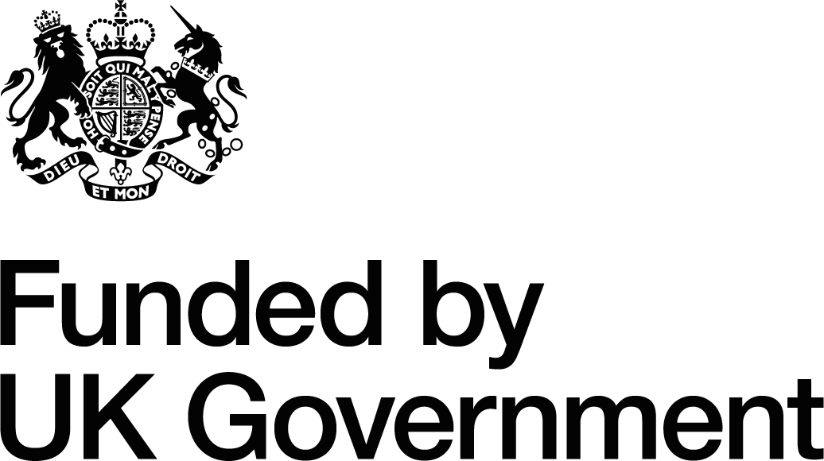

Creu Conwy

Town Teams

Invitation to Quote - Brief:

Development and delivery of collaborative, cultural, locally-led projects – Conwy Round 2

Project Reference: Creu Conwy UK SPF Town Teams 2025/Conwy Round 2

To express an interest and request an Invitation to Quote form email creu@conwy.gov.uk

The deadline for submissions is midday 26/08/2025

  - INTRODUCTION AND BACKGROUND

  - Culture and the arts contribute more than £11.8 billion pounds to the UK economy each year. Conwy County Borough Council (CCBC) values the contribution made by our cultural sector and it is reflected as a priority action in our Corporate Plan 2022-2027. Creu Conwy, ‘Creating the spark a Cultural Strategy for Conwy County Borough 2021-2028 has been developed to deliver against these objectives and to drive community renewal.

  - The Town Teams are a key element of Creu Conwy’s delivery. Focused on the county’s five largest towns of Abergele, Bae Colwyn, Conwy, Llandudno and Llanrwst their key purpose is; to bring key people, groups and organisations together to deliver distinctive, locally-led cultural projects that adopt a creative place-making approach which is responsive to local interest and need.

  - The Town Teams were initiated in 2022 and have cross-sector representation (which includes local creatives, local businesses, community groups and organisations and Town Councils), supported by the Creu Conwy Team. They have since met regularly to develop project ideas and action plans. Following a successful Creu Conwy UKSPF bid the Town Teams were allocated funding which enabled them to deliver a hugely successful programme of activity between September 2023 to March 2025 – details of the projects can be viewed here

1.4 The UK Shared Prosperity Fund aims to improve pride in place and increase life chances across the UK investing in communities and place, supporting local business, and people and skills. Visit Cronfa Ffyniant Gyffredin: Gogledd Cymru - Overview to find out more.

2.0 CREU CONWY TOWN TEAMS 2025 – ABOUT THE PROJECT

2.1 CCBC’s Culture, Libraries and Information section has successfully accessed the UK Shared Prosperity Fund (UKSPF) to drive the delivery and implementation of the Creu Conwy Cultural Strategy and Library and Information Strategy with a focus culture led renewal to support wellbeing.

2.2 As part of the wider Creu Conwy programme of activity we would like to commission projects across the five Town Team areas with the aim of:

- Delivering impactful cultural projects that build on their success and celebrate sense of place
- Removing barriers to participation and increasing access to free and low cost cultural experiences
- Supporting community wellbeing by offering opportunities that bring people together tackling social isolation
- Encouraging footfall into town centres and enhancing the visitor experience to drive economic growth
- Promoting the Welsh Language, culture and local heritage
- Encouraging collaborative working and opportunities
- Supporting opportunities for local creatives
- Developing and strengthening the capacity of the Town Teams and community and cultural networks across the county

- THE REQUIREMENTS

3.1 CCBC is inviting quotes from groups and organisations who are in a position to plan, promote
and deliver exciting projects under the Creu Conwy Town Team banner.

Important considerations include:

- Ability to demonstrate strong linkages with the Creu Conwy Town Team
- A strong focus on Culture, Heritage and Welsh language
- Inclusivity and removing barriers to cultural participation through free/ low cost and accessible activities
- Ability to demonstrate collaborative / partnership working with the Town Team
- Projects must clearly demonstrate community benefit
- A deep understanding of the local area with projects that are placebased, locally relevant and relatable
- Knowledge, experience and skills required to deliver the outlined project

Projects supported by this commission will be required to:
- Provide a project plan with allocated roles, responsibilities and timescales
- Ensure that all activities are well managed and risk assessed
- Have necessary licenses and insurances in place and sign a project agreement
- Work collaboratively with the respective Creu Conwy Town Team
- Follow required brand guidelines and funder acknowledgements
- Demonstrate value for money and test the market for quality as well as cost (e.g. with the bulk of the funds spent on the project and not management costs)
- Provide information for reporting and evaluation
- Be deliverable between July 2025 and January 2026

4. BUDGET

Quotes are invited for projects valued between £1,000 and £3,000 (excluding VAT). Costing to be inclusive of artist fees, equipment, licensing, venue hire, administration and all other costs.

For information we had £40,000 in total and allocated £8000 of UKSPF funding to each Town Team area (Abergele, Bae Colwyn, Conwy, Llandudno and Llanrwst) in Round 1.

5. TIMESCALE

Milestones | Provisional Date
Quotation submissions | Midday 26/08/2025
Contract award | 05/09/2025
Contract end (All agreed outputs delivered all evidence supplied and invoices submitted for payment) | 31/01/2026

6. ADDITIONAL INFORMATION

Conwy Culture | Conwy Culture

CCBC Welsh Language Standards

Anti-racist Wales Action Plan | GOV.WALES

Wellbeing of Future Generations (Wales) Act
Cronfa Ffyniant Gyffredin: Gogledd Cymru - Overview

