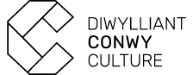

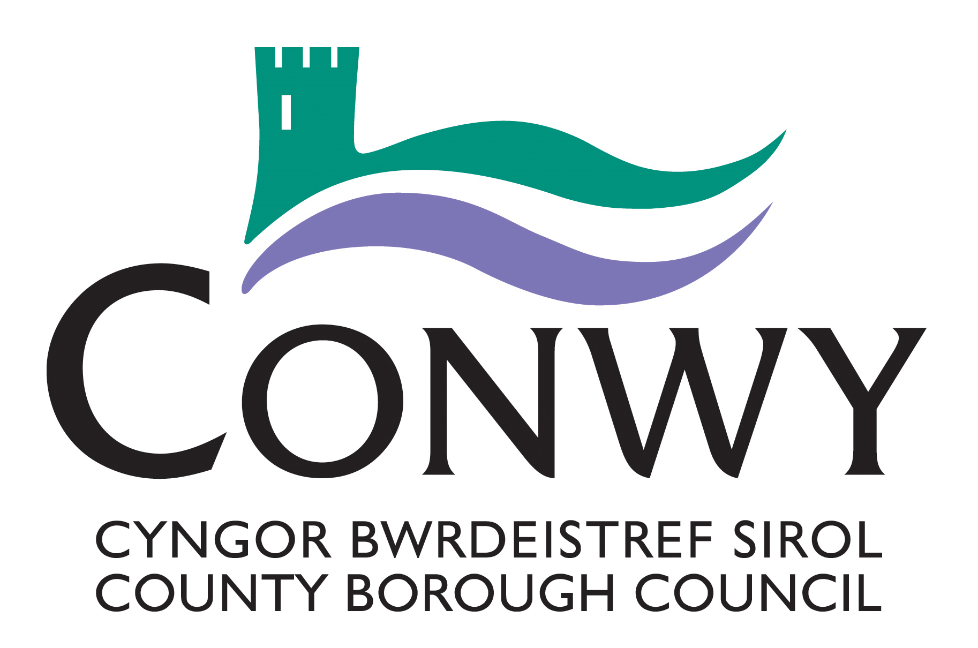

**Creu Conwy Cymunedau Creadigol**

**Open Call – Creative Practitioner Opportunity**

1. **INTRODUCTION** **TO THE PROJECT**

Cymunedau Creadigol is a new community arts project which is being led by CCBC’s Culture, Libraries and Information team as part of the delivery of the Creu Conwy Cultural Strategy. Cymunedau Creadigol is funded by Arts Council of Wales’, via [Create](https://arts.wales/funding/create) a National Lottery Arts Funding programme

Cymunedau Creadigol will offer an accessible and inclusive community arts programme for adults, children and young people. Participants will have the chance to discover new art forms, develop their creative skills and self-expression in a safe and supportive environment.

The project will take place across Conwy to ensure maximum geographical reach with delivery focused in the five largest towns – Abergele, Colwyn Bay, Conwy, Llandudno and Llanrwst. Venues are likely to include Conwy Culture Centre, Conwy Libraries and Venue Cymru whilst reaching out to Family Centres, Learning disability teams and other community organisations / groups. Delivery will culminate in exhibition / performance opportunities.

The project has 4 key objectives:

1. To offer opportunities for adults, children, young people & families to engage with the arts
2. To offer work and development opportunities to local creative practitioners
3. To embed the Wellbeing of Future Generations Ways of Working through an integrated collaborative approach that supports the preventative agenda
4. To remove barriers to cultural participation and develop arts audiences in Conwy county

In total, the project will deliver 160 artist-led sessions + 10 engagement sessions broken down as below:

* 2 engagement sessions delivered in each of the 5 town areas
* Children and Young People’s delivery – 16 (½ day) sessions delivered in each of the 5 areas
* Adult Workshops – 16 (½ day) sessions delivered in each of the 5 areas

We anticipate commissioning 5 Artists / Creative facilitators, with each focusing on delivery in one of the geographical areas.

**2.0 THE REQUIREMENTS**

We are seeking expressions of interest from Creative practitioners who have experience of delivering successful community arts projects and working inclusively with people of all ages and abilities in community settings. The Creative practitioners will be supported by the Culture team and a freelance Project Coordinator.

The requirement will be to deliver:

* 2 Engagement sessions
* 16 sessions targeted at an adult group
* 16 sessions targeted at a children, young people and family groups
* A show case in the form of an exhibition or performance (dependent on art form)

The key knowledge, skills and experience required include:

* Experience of delivering creative workshops in community settings
* Highly organised with excellent communication skills
* Experience of working with adults, children and young people
* Experience of working with bilingual communities
* Experience of working with vulnerable people with additional needs (i.e. people experiencing mild to moderate mental health challenges / people with learning disabilities) in community settings
* A passion for the arts and understanding of the transformative potential of cultural participation
* Awareness and understanding of working in an inclusive way with diverse communities
* Sensitivity to the needs of different participants and willingness to work flexibly to enable them to engage on a level and in a format that they are comfortable with
* Familiar with risk assessments, Safeguarding procedures and willing to work in accordance with CCBC’s [Safeguarding Policy](https://www.conwy.gov.uk/en/Resident/Social-Care-and-Wellbeing/Im-worried-about-somebody/assets/documents/Corporate-Safeguarding-Policy-2023.pdf)
* Knowledge and understanding of Welsh language and culture to include awareness of: [CCBC Welsh Language Standards](https://www.conwy.gov.uk/en/Council/Welsh-Language-Standards.aspx)
* Understanding of GDPR and able to manage personal data appropriately

**3.0 BUDGET**

The budget for 32 sessions + 2 engagement sessions per town hub is £6,800.

Your quote should be inclusive of all preparation, materials and all costs except VAT (if applicable). There is an additional budget available of up to £500 to support exhibition / performance costs.

**4.0 TO EXPRESS AN INTEREST**

To be considered for this opportunity please respond to the questions below (maximum of 2 sides of A4):

1. Please give recent examples of community arts sessions that you have facilitated – what went well and what were the challenges?
2. Please provide an outline proposal of how you would approach these community sessions. Please include chosen art form(s), any potential exhibition / performance opportunities and target age range for the children and young people session. In addition, please indicate if you have a preference in relation to area (Abergele, Bae Colwyn, Conwy, Llandudno and Llanrwst)?
3. Please share your understanding and experience of Welsh culture and working in bilingual settings. Please indicate if you are happy to facilitate sessions through the medium of Welsh?
4. Please provide contact details for two references from recent contracts, which are relevant to the requirements of this opportunity.

We offer an inclusive application process and accept submissions in the following formats –

* Written (maximum 2 sides of A4 submitted in Word of PDF format)
* Audio format (mp3)
* Video (MP4)
* BSL

Submissions will be evaluated and scored by a panel in relation to the required criteria.

Please submit your expression of interest by email to – [creu@conwy.gov.uk](mailto:creu@conwy.gov.uk) by 21/07/25