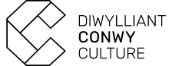

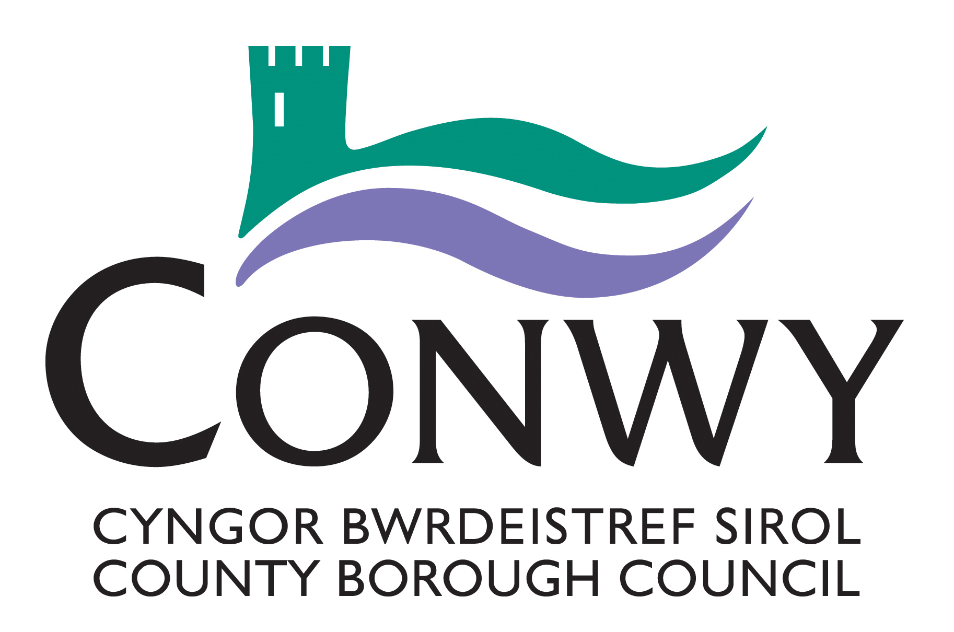

**Creu Conwy Cymunedau Creadigol**

**Open Call - Freelance Coordinator Opportunity**

1. **INTRODUCTION** **AND BACKGROUND**

Culture and the arts contribute more than £11.8 billion pounds to the UK economy each year. Conwy County Borough Council (CCBC) values the contribution made by our cultural sector and it is reflected as a priority action in our Corporate Plan 2022-2027. [Creu Conwy, ‘Creating the spark a Cultural Strategy for Conwy County Borough 2021-2028](https://www.conwy.gov.uk/en/Council/Have-your-say/assets/documents/Creu-Conwy-%E2%80%93-Cultural-Strategy-for-Conwy-County-Borough-2021-2026.pdf) has been developed to deliver against these objectives and to drive community renewal.

Creu Conwy Cymunedau Creadigol is a new community arts project which is being led by the CCBC’s Culture, Libraries and Information team as part of the delivery of the Creu Conwy Cultural Strategy.

Creu Conwy Cymunedau Creadigol is funded by Arts Council of Wales’, via [Create](https://arts.wales/funding/create) a National Lottery Arts Funding programme

1. **ABOUT THE PROJECT**

Creu Conwy Cymunedau Creadigol will offer an accessible and inclusive community arts

programme for adults and children and young people. Participants will have the chance to

discover new art forms, develop their creative skills and self-expression in a safe and

supportive environment. The project will be delivered across the county with delivery

focused in the 5 largest towns – Abergele, Bae Colwyn, Conwy, Llandudno and Llanrwst.

Delivery will culminate in an exhibition / performance showcase.

The project has 4 key objectives:

1. To offer opportunities for adults, children, young people & families to engage with the arts
2. To offer work and development opportunities to local creative practitioners
3. To embed the Wellbeing of Future Generations Ways of Working through an integrated collaborative approach that supports the preventative agenda
4. To remove barriers to cultural participation and develop arts audiences in Conwy county

In total the project will deliver 160 artist-led sessions broken down as below:

* 2 engagement sessions delivered in each of the 5 areas
* Children and Young People’s delivery – 16 (½ day) sessions delivered in each of the 5 areas
* Adult Workshops – 16 (½ day) sessions delivered in each of the 5 areas

**3.0 THE REQUIREMENTS**

We are a seeking a Freelance Project Coordinator who are has experience of successfully delivering community arts projects and working inclusively with people of all ages and abilities in community settings. This exciting opportunity will offer the chance to shape the project and make a positive difference to people and communities across the county of Conwy

The key knowledge, skills and experience required includes:

* Experience of coordinating and planning creative programmes and workshops in community settings
* Experience of engagement and supporting access
* Awareness and understanding of working in an inclusive way with vulnerable people and diverse communities
* A passion for the arts and understanding of the transformative potential of cultural participation
* Highly organised with excellent communication skills
* Adaptable and able to problem solve
* Experience of working with bilingual communities
* Experience of working with adults, children and young people
* Familiar with risk assessments, Safeguarding procedures and willing to work in accordance with CCBC’s [Safeguarding Policy](https://www.conwy.gov.uk/en/Resident/Social-Care-and-Wellbeing/Im-worried-about-somebody/assets/documents/Corporate-Safeguarding-Policy-2023.pdf)
* Understanding of GDPR and able to manage personal data appropriately
* Knowledge and understanding of Welsh language and culture
* Willing to work in accordance with: [CCBC Welsh Language Standards](https://www.conwy.gov.uk/en/Council/Welsh-Language-Standards.aspx)

The Freelance Project Coordinator will assist with all aspects of the project – examples of activity / tasks will include:

* Assist with the recruitment of five Creative practitioners and support the project team and partners with the shortlisting and selection process
* Act as point of contact for the commissioned artists, venues and support with making connections & developing partnerships with a variety of groups and organisations
* Attending meetings to plan and update on delivery
* Support with promotion and engagement
* Support with developing and scheduling the project programme
* Work with artists and venues to enable safe / accessible sessions and ensure risk assessments are in place
* Support the Creative Practitioners with the curation of temporary exhibition/ installations or performances to showcase the work at end of the project.
* Support project team with reporting, ensuring project records are kept, data collection and evaluation

**Project timeline**

**Initiation**

June – July 2025 – Commissioning Creatives and Freelance Support. Identifying groups / partners. Delivery planning with creatives – scheduling venues etc.

July– August 2025 – Marketing, promotion and engagement

**Delivery**

August – October – phase 1

November – January – phase 2

**Project close**

February - Exhibitions / Performance / Show Case / Evaluation, project reporting and close

The budget for this piece of work is £6000 inclusive of all costs & materials but excluding VAT.

**To express an interest in this opportunity please complete the Invitation to Quote Form. To request a form email** [**creu@conwy.gov.uk**](mailto:creu@conwy.gov.uk) **The deadline for submissions is midday 30/06/25.**