
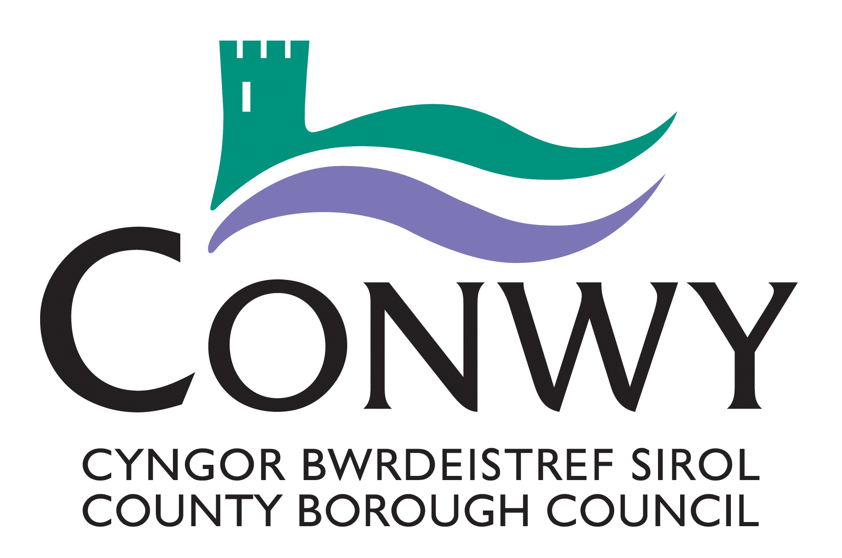

Creu Conwy Cymunedau Creadigol
Open Call - Freelance Coordinator Opportunity

Invitation to Quote Form

Notes for Completion

- If the question does not apply to you / your Organisation, please state ‘N/A’ in the response section of the question.

- Please complete this quotation form and email your submission to: Creu@conwy.gov.uk before the submission receipt deadline – midday 30/06/25.

Selection / Evaluation of Submissions

To ensure a fair process the evaluation will be undertaken by an Evaluation Panel who will follow a systematic process as detailed below. This comprises scoring the submitted information against the required standard. The scoring system will give a score for your ability to meet each criterion. The weighting for the scoring as shown below:

Evaluation Criteria | Weighting
Q1 – Basic Information About Your Organisation. | For information purposes.
Q2, Q3, Q4, Q5, | Will be risk assessed
Q6 Project specific Information
6.1) | 25%
6.2) | 25%
6.3)  6.4) | 20%  15%
Q7 Price Schedule – to be scored in relation to value for money. | 15%

2 references will be requested prior to contract award

1.0 POTENTIAL SUPPLIER INFORMATION AND CONTACT DETAILS

Contact name(s):
Organisation name:
Address(es):
Position(if applicable):
Telephone number(s):
E-mail addresse(s):

2.0 INSURANCE

Please provide details of insurances you hold (Public Liability, Professional Indemnity, Employer liability)
and confirm that if awarded this contract you are willing to obtain insurance to required level?

3.0 DATA PROTECTION

Confirm commitment to managing personal information in relation to the commission accordance with the Data Protection Act (2018).

Please select:
Yes
No

- SAFEGUARDING

Do you / your organisation agree to work in accordance with Conwy County Borough Council’s Safeguarding Policy?

Please select:
Yes
No

- CONFLICT OF INTEREST

Do you / your organisation have any association, either directly or indirectly, with any Member or employee of Conwy County Borough Council, or service provider acting on behalf of Conwy County Borough Council, that could constitute a conflict of interest (such as a financial, economic or personal interest)?

Please select and provide details
Yes
No

6.0 PROJECT SPECIFIC INFORMATION (Evaluation Criteria Weighting: 85% Quality)

6.1 Please give recent examples of relevant projects that you have co-ordinated – please give details of what your role involved, include what went well, what the challenges were and how you overcame them? (Weighting 25%) Max word count - 300

6.2 Please outline how you would approach this piece of work, including how you would prioritise tasks and manage your time (Weighting 25%) Max word count - 250

6.3 Please share your understanding and experience of Welsh culture and working in bilingual settings. Please indicate if you are happy to facilitate sessions through the medium of Welsh? (Weighting 20%) Max word count - 150

6.4 This role will require travel around the county of Conwy and flexibility in relation to attending meetings and sessions. Please provide details of how you will manage this? (Weighting 15%) Max word count - 150

7.0 Price AND COSTING Schedule (Evaluation Criteria Weighting: 15% Price – to be evaluated according to value for money)

7.1 The budget for this piece of work is £6000 Inclusive of all costs but excluding VAT. Please provide a breakdown of all costs and include number of hours that will be allocated to the project and hourly rate (Inclusive of travel, admin, etc.). If more than one person will be undertaking work please provide details and insert any additional costs / lines as required.

Project activity | Hourly Rate £ | Number of hours allocated to project | Total Costs (£)  Excluding VAT
Project Coordinator
 | - | 0 | 0
Total Quotation / Cost (£)

8.0 DECLARATION

I / We confirm the information provided is accurate to the best of my / our knowledge and that I / We acknowledge and accept that any false information could result in our application being rejected or, in the event that any false declaration is discovered after the award of any contract, may lead to the rescission of any contract awarded.

Signature: |  | Enw (printed):
Date: |  | Title:
Personal data gathered through this form will be stored securely and only relevant Conwy County Borough Council staff will have access to it for the purposes of this commissioned piece of work
For Conwy County Borough Council’s full Privacy statement, please visit: https://www.conwy.gov.uk/en/Council/Access-to-Information/Privacy-Notices/How-Conwy-County-Borough-Council-uses-your-Information.aspx for full details or a printed version is available on request.

